List of software’s need to be installed

1 ) <https://nodejs.org/en/download/>

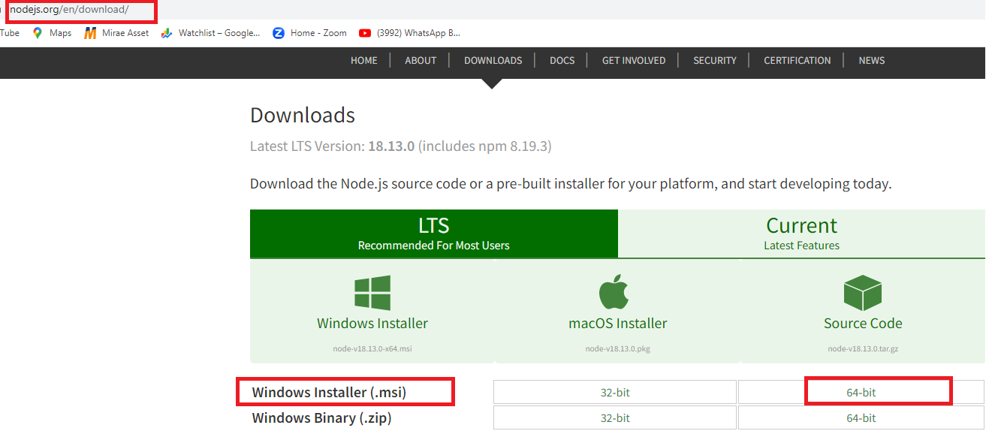

2) <https://dev.mysql.com/downloads/windows/installer/8.0.html>

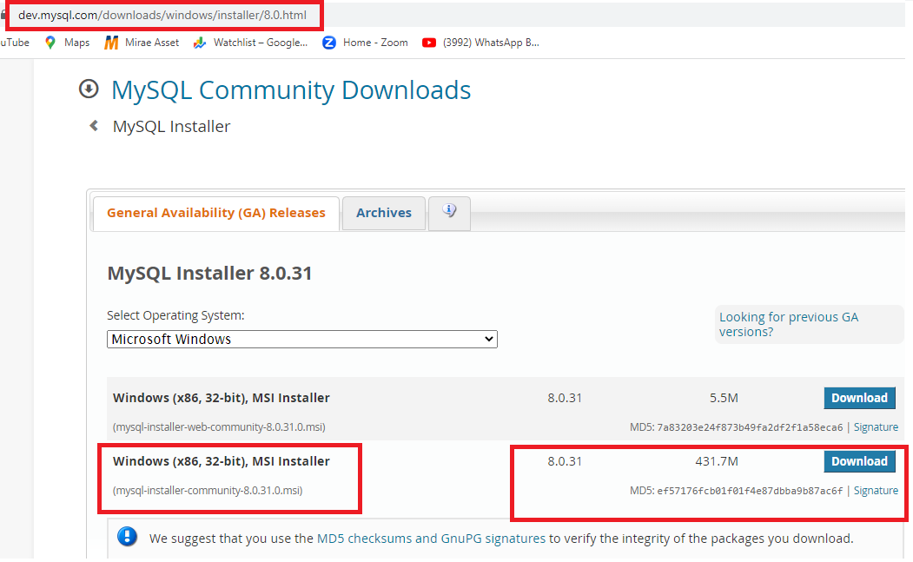

3) <https://www.mongodb.com/try/download/community>

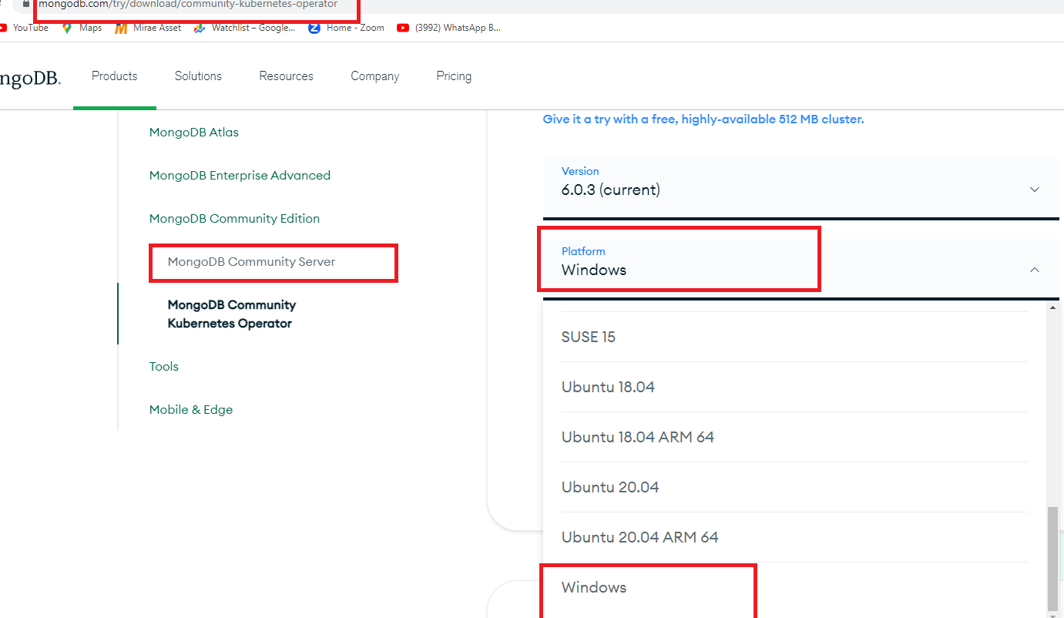

4) <https://git-scm.com/>

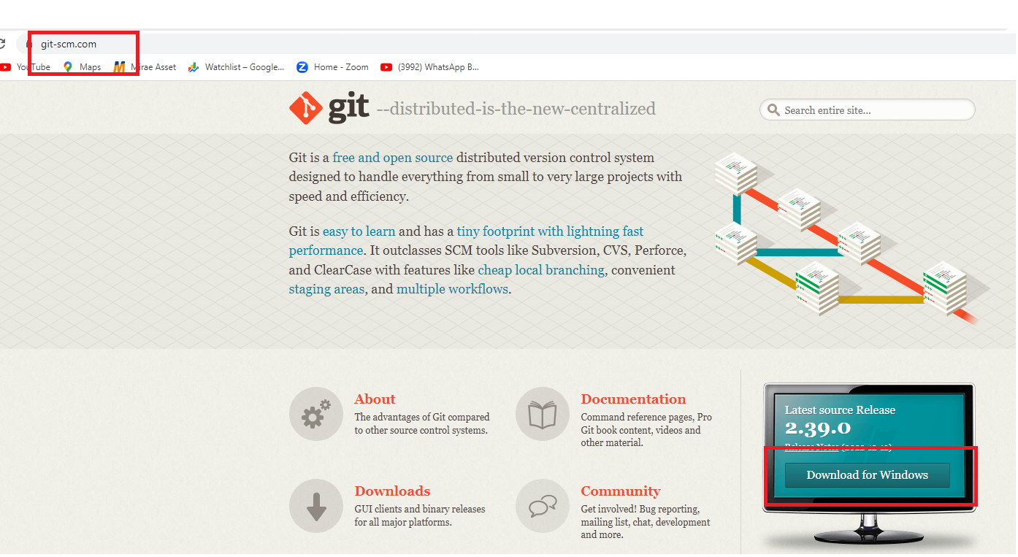

5) <https://www.jenkins.io/download/>

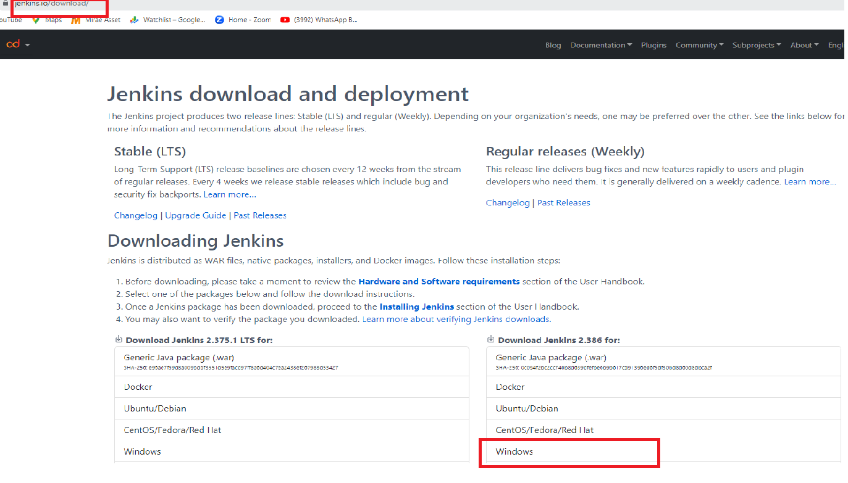

Editor

<https://code.visualstudio.com/docs/nodejs/angular-tutorial>

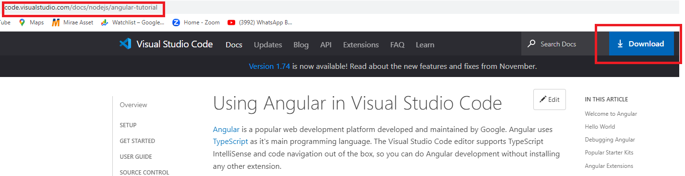

6) <https://spring.io/tools>

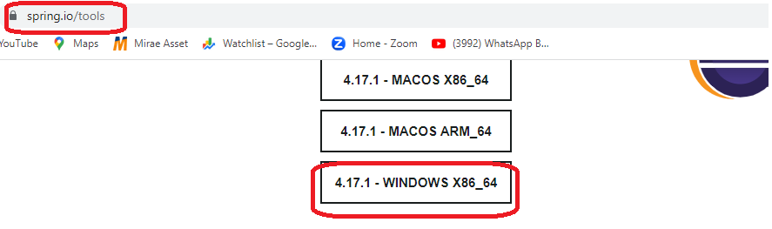

7) <https://www.enterprisedb.com/downloads/postgres-postgresql-downloads>

